**Chris Lombardo**

**Final Project: Super Chess Fun-Times**

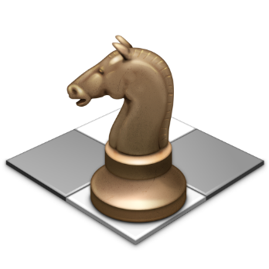

**Overview:**

I plan to make a text-based chess program. This program will be a vehicle for two human players to play chess with one another, and will NOT include an AI or computer player. I think this project will be especially interesting, because I do not know the rules of chess, and will have to research that as well. I will use the standard Python module and NOT Pygame.

**Function:**

Each turn, the program will take two inputs from each player: what piece they would like to move, and where they would like to move it. It will do this through coordinates (ex: b4 to f8).

**Denial of Invalid Input:**

The program will display an error message if the user does not enter real coordinates, if the square the user wants to move does not contain a piece, if it contains a piece that is not the users, if the square that the user wants to move to contains a piece, if the move that the user wants to do does not agree with the movement rule of the chess piece, or if the path that the user wants the piece to take is blocked by another piece.

**Screenshot:**

__1____2___3_____4____5____6_____7____8_

a | R | k | B | Q | K | B | k | R |

|____|____|_____|______|____|_____|_____|____|

b | p | p | p | p | p | p | p | p |

|____|____|_____|_____|_____|_____|_____|____|

c | | | | | | | | |

|____|____|_____|_____|_____|_____|_____|____|

d | | | | | | | | |

|____|____|_____|_____|_____|_____|_____|____|

e | | | | | | | | |

|____|____|_____|_____|_____|_____|_____|____|

f | | | | | | | | |

|____|____|_____|_____|_____|_____|_____|____|

g | p | p | p | p | p | p | p | p |

|____|____|_____|_____|_____|_____|_____|____|

h | R | k | B | K | Q | B | k | R |

|____|____|_____|______|____|_____|_____|____|

This is what I predict my board will look like. I have put the pieces on the classic 8x8 board with the x-axis labeled with numbers and the y-axis labeled with letters. I may consider adding more chess-like characters or even chess piece images if I so decide.

**Thoughts:**

I predict that some of the most difficult parts of the program will be:

1. Avoiding hard-coding things for each space/piece on the board. This could take up a lot of lines of code and make editing and problem fixing less easy.
2. Making sure the chess pieces can move the right way, specific to the type of piece. This includes making sure my program knows which spots on the board are next to each other and diagonal from eachother.